**ANNA ADARSH**

**COLLEGE FOR WOMEN (AUTONOMOUS)**

**ANNANAGAR - CHENNAI**

**COLLEGE CODE : 1353**

***FITFLEX***

FitFlex : **Your Personal**

**Fitness Companion (React Application)**

***INTRODUCTION :***

FitFlex is a revolutionary fitness app designed to transform your workout experience. It offers an intuitive interface, dynamic search, and a vast library of exercises for all fitness levels. Join FitFlex to embark on a personalized fitness journey and achieve your wellness goals.

***TEAM ID : SWTID1741176409150272***

***TEAM MEMBERS :***

**LEELA M – CODING , VIDEO EDITING**

**EMAIL ID : www.leela978@gmail.com**

**SWETHA S – CODING**

**EMAIL ID : punithaswetha06@gmail.com**

**SUPRAJA M – CODING**

**EMAIL ID : suprajamanohar2185@gmail.com**

**SRI HARINI S - DOCUMENTATION**

**EMAIL ID : sriharinisasikumar@gmail.com**

**VARUNA SHRIYA P - DOCUMENTATION**

**EMAIL ID : varunashriya24122004@gmail.com**

# PROJECT OVERVIEW

***PURPOSE :***

Our innovative fitness app is meticulously designed to revolutionize the way you engage with exercise routines, catering to the diverse interests of both fitness enthusiasts and seasoned workout professionals. With a focus on an intuitive user interface and a comprehensive feature set, FitFlex is set to redefine the entire fitness discovery and exercise experience. Crafted with a commitment to user-friendly aesthetics, FitFlex immerses users in an unparalleled fitness Journey. Effortlessly navigate through a wide array of exercise categories with features like dynamic search, bringing you the latest and most effective workouts from the fitness world. From those embarking on their fitness journey to seasoned workout aficionados, FitFlex embraces a diverse audience, fostering a dynamic community united by a shared passion for a healthy lifestyle. Our vision is to reshape how users interact with fitness, presenting a platform that not only provides effective exercise routines but also encourages collaboration and sharing within the vibrant fitness community.

***Features of FitFlex :***

***Exercises from Fitness API :*** Access a diverse array of exercises from reputable fitness APIs, covering a spectrum of workout categories and catering to various fitness goals.

***Visual Exercise Exploration :*** Engage with workout routines through curated image galleries, allowing usersexplore different exercise categories and discover new fitness challenges visually.

***Intuitive and User-Friendly Design :*** Navigate the app seamlessly with a clean, modern interface designed optimal user experience and clear exercise selection.

***Advanced Search Feature :*** Easily find specific exercises or workout plans through a powerful search feature, enhancing the app's usability for users with varied fitness preferences.

***ARCHITECTURE :***

***Technical Architecture :***

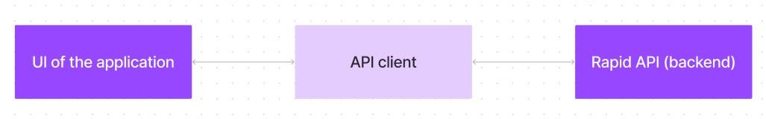

The architecture focuses on a **React.js-based frontend** paired with **Rapid API** to fetch and manage data from external APIs.

Here's a breakdown of the core tools:

▪***React Router DOM :*** Enables seamless navigation between different components and pages.

* ***AxioS :*** Used to fetch data from APIs.
* ***Bootstrap/Tailwind CSS :*** For styling and creating a responsive and clean design.
* ***RapidAPI :*** A platform for accessing various external APIs, including fitness data and videos.

***SETUP INSTRUCTIONS :***

***PRE-REQUISITES :***

Here are the key prerequisites for developing a frontend application using React.js:

***Node.js and npm :***

Node.js is a powerful JavaScript runtime environment that allows you to run JavaScript code on the local environment. It provides a scalable and efficient platform for building network applications. Install Node.js and npm on your development machine, as they are required to run JavaScript on the serverside

***INSTALLATION INSTRUCTIONS :***

***React.js :***

React.js is a popular JavaScript library for building user interfaces. It enables developers to create interactive and reusable UI components, making it easier to build dynamic and responsive web applications. Install React.js, a JavaScript library for building user interfaces.

***Create a new React app :***

npx create-react-app my-react-app

Replace my-react-app with your preferred project name. ***Navigate to the project directory :***

cd my-react-app

***Running the React App :***

With the React app created, you can now start the development server and See your React application in action. Start the development server: **npm start**

* This command launches the development server, and you can access **HTML, CSS, and JavaScript** : Basic knowledge of HTML for creating the structure of your app, CSS for styling, and JavaScript for client-side interactivity is essential.
* ***Version Control :*** Use Git for version control, enabling collaboration and tracking changes throughout the development process. Platforms like GitHub or Bitbucket can host your repository.
* ***Development Environment :*** Choose a code editor or Integrated Development Environment (IDE) that suits your preferences, such as Visual Studio Code, Sublime Text, or Web Storm.

***Install Dependencies :***

Navigate into the cloned repository directory and install libraries:

cd fitness-app-react npm install

***Start the Development Server :***

To start the development server, execute the following command: npm start

***Access the App :***

You should see the application's homepage, indicating that the installation and setup were successful. You have successfully installed and set up the application on your local machine. You can now proceed with further customization, development, and testing as needed.

***Folder Structure :***

***Client :* Organization of the React Application** The React application for **FitFlex** is structured in a way that ensures clean separation of concerns, scalability, and easy maintainability. Below is the breakdown of the folders and their contents:

* ***src/ :*** The main source folder containing all the application's logic.
* ***components/ :*** Stores reusable components used across different pages. These components are independent, functional units like buttons, cards, and modals.
* ***Example :*** Navbar.js, ExerciseCard.js, SearchBar.js,

Footer.js.

***pages/ :*** Contains React components that represent

individual pages, each corresponding to a route in the app.

* ***Example :*** Home.js, Category.js, ExerciseDetails.js.

assets/: Stores static files such as images, videos, and other media.

* ***Example :*** logo.png, hero-image.jpg. ***styles/ :*** Holds all the styling files for the project, whether it's CSS files, or Sass if used.
* ***Example :*** main.css, buttons.css, responsive.css. ***hooks/ :*** Contains custom hooks for managing reusable logic.
* ***Example :*** useFetchData.js, useLocalStorage.js.

***utils/ :*** Contains helper functions, constants, and utilities that assist with various tasks like data manipulation, validation, etc.

* ***Example :*** api.js, formatDate.js.

***Running the Application :***

***To run the FitFlex React app locally :***

git clone <repo-url>cd fitness-app-react Clone the project from the repository.

npm install git clone <repo-url cd fitness-app-react ***Install dependencies :*** npm install

**Start the frontend server**

npm start

This will start the development server, and you can view the app by navigating in your broswer.

***Component Documentation : Key Components :***

***Navbar :***

***Purpose :*** Displays navigation links to different sections of the app.

***Props :*** links (Array): List of navigation links.

***Category :***

***Purpose :*** Displays exercises grouped by categories (e.g., Cardio, Strength, Flexibility).

***Props :*** categoryId (String): The category ID to fetch exercises for.

***ExerciseDetails :***

***Purpose :*** Displays detailed information about a specific exercise, including images, descriptions, and related videos.

***Props :*** exerciseId (String): The ID of the exercise to fetch.

***SearchBar :***

***Purpose :*** Allows users to search for exercises by name.

***Props :*** query (String): The search query entered by the user.

***State Management :***

***Global State :***

* The **React Context API** is used to manage global state across components. This is particularly useful for managing the following:
* ***User Authentication :*** To keep track of the logged-in state, user details, and session across the app.
* ***Theme Preferences :*** If the user prefers a light/dark theme, this can be stored globally and accessed anywhere in the app.

***Local State :***

* Each component is responsible for managing its local state using **useState** and **useEffect**. For
* ***Example :***

***ExerciseDetails :*** Manages the state for the exercise data fetched from the API.

***SearchBar :*** Manages the state for the search query and results.

***User Interface :***

Unfortunately, I cannot provide screenshots directly here, but the **FitFlex** app includes the following key UI features:

1. ***Homepage :*** A welcoming hero section with a search bar and a list of categories.
2. ***Category Page :*** Displays exercises grouped by category, with clear navigation.
3. ***Exercise Page :*** Displays details of a selected exercise, including images, descriptions, and related YouTube videos.

***Styling :***

***CSS Frameworks/Libraries :***

* The application uses **Bootstrap** (or **Tailwind CSS**, if chosen) for the styling of componentslike buttons, grids, and navigation bars.
* **Bootstrap** is used for easy styling with predefined classes.
* **Tailwind CSS** can also be used for utility-first styling.
* ***Theming :* FitFlex** supports dark/light mode, and the theming can be customized globally using the  **Context API** to switch between themes.

***Testing :***

***Testing Strategy :***

* ***Unit Testing :*** Using **Jest** and **React Testing Library** to test individual components for rendering and functionality.
* ***Integration Testing :*** Ensures that components work together correctly, espically when interactingwith APIs.
* ***End-to-End Testing :*** Tools like **Cypress** or **Puppeteer** could be used to test the entire application flow.

***Code Coverage :***

Jest and **React Testing Library** are set up to ensure good test coverage. Tools like **Istanbul** or **Codecov** can be used to measure code coverage and ensure that critical parts of the application are tested.

***Screenshots or Demo :***

***HOME PAGE :***

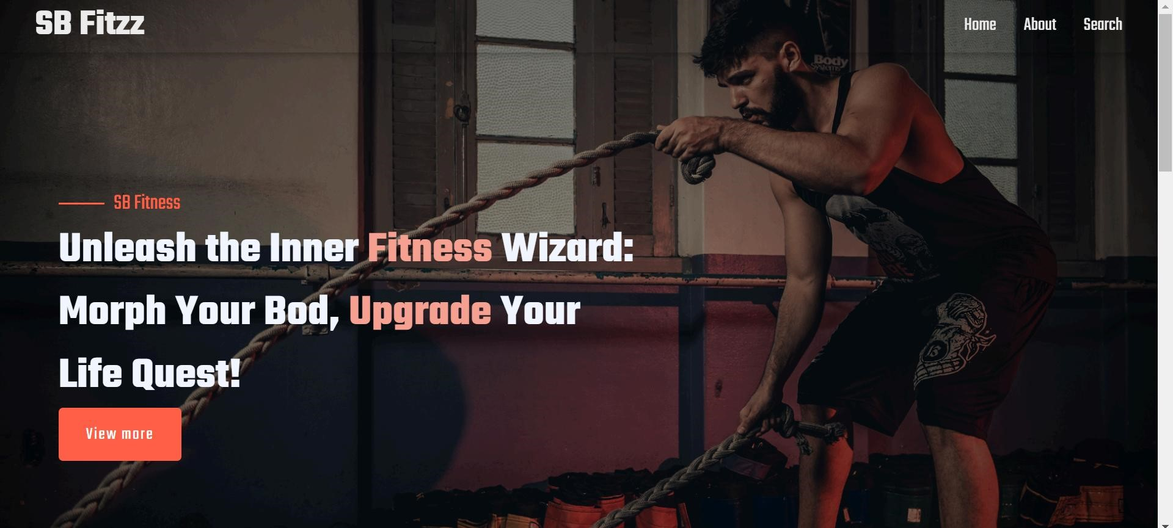

***ABOUT :***

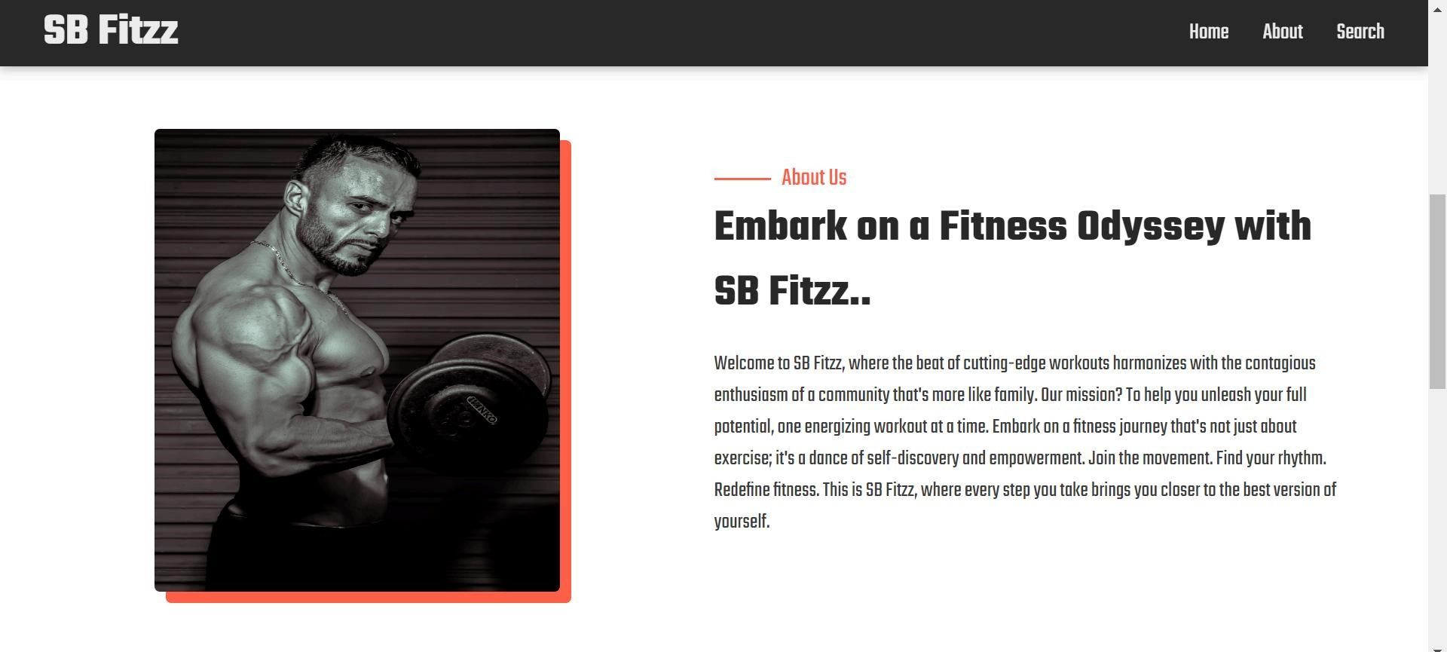

***SEARCH :***

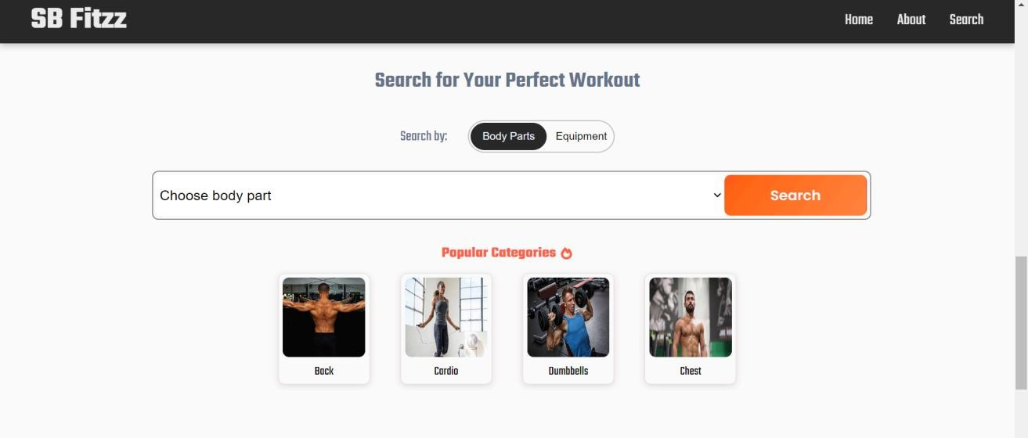

***CATEGORY :***

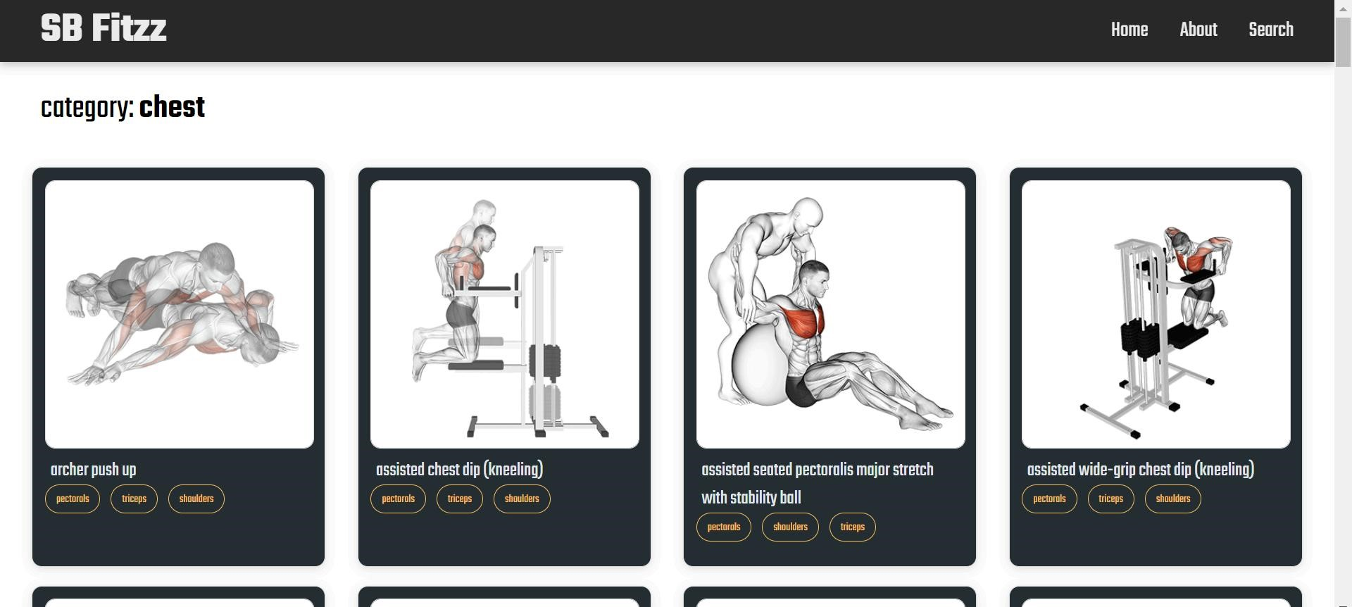

***EXERCISE :***

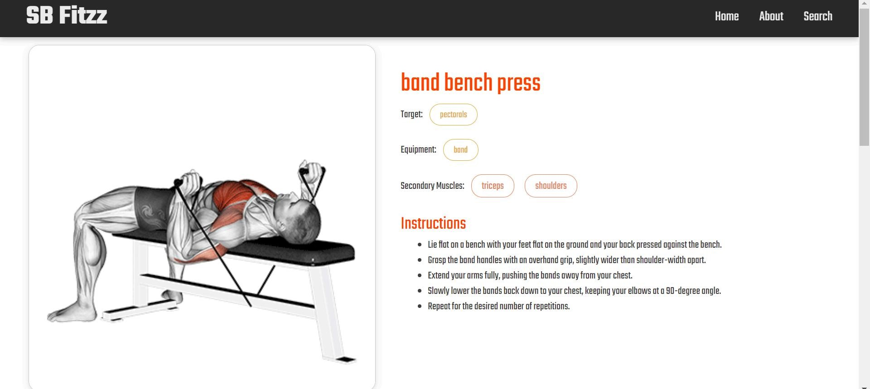

***Known Issues :***

* ***Performance Issues :*** Some API requests may take longer to load depending on network speed or server response time.
* ***Responsive Design :*** While most pages are responsive, certain pages may need adjustments for smaller screen sizes.

***Future Enhancements :***

* ***User Profiles :*** Allow users to create profiles, save their progress, and track their workouts.
* ***Animated Transitions :*** Improve user experience by adding animations when navigating between pages or actions.
* ***Advanced Search Filters :*** Include more filters like difficulty level, duration, and equipment for more refined searches.